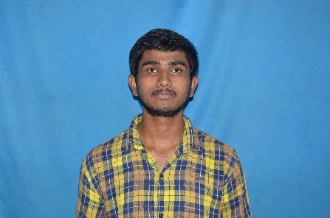

Innovative & Creative Mechanical Engineer, seeking a core-related challenging opportunity that has an impact on organizational and personal growth and development

saikumarsuruneni@gmail.com

**SSC** (2015)

*Sri Krishnaveni Talant School, Jannaram*

SSC with 7.3 CGPA

**DESIGN AND ANALYSIS** (MINI-PROJECT)

*Done virtually*

Design and Analysis on old jeep Wrangler chassis to find Material and Cross-Section to use

Hindi

Telugu

English

**HOBBIES**

Cooking

Travel

Music

Movie

**SAIKUMAR**

SURUNENI

**ABOUT ME**

+91 9515775499

in/saikumar-suruneni-260749188

**LANGUAGES**

**SKILLS**

Auto-cad



Solidworks



Ansys



**B. Tech in Mechanical Engineering** (2021)

*Vivekananda Institute of Technology & Sciences*

I am pursuing B. Tech final year

**Diploma in Mechanical Engineering** (2018)

*SRRS Govt. Polytechnic, Sircilla*

with 74.1%

**INTERNSHIP**

**PROJECTS**

**EDUCATION**

**ELECTRO-MAGNETIC REPULSIVE HAMMER** (DIPLOMA)

*Made a proto-type to demonstrate*

Works on the principle of electromagnetic repulsive mechanism

**Storekeeper and Servicemen** (TVS Showroom)

*VENKATESHWARA MOTORS, Jannaram*

I have done my internship for 4 Weeks